Shree Ramswaroop Memorial University

A Project Report on
‘The Silver Screen Symphony :
Data Driven Insights for Modern Streaming Market’

Showcase Link :
https://thesilverscreensymphony.netlify.app

By Inzmam un Nabi Khan (202410101150099) & Alok Shrivastaw (202410101150096)
Course\Branch : Btech CS(DS + AI)
Group : 34
Year\Sem : 2nd Year, 3rd Sem

Subject : Data Analytics & Reporting
Subject Code : UCS3804
Faculty Incharge : Ms. Deepika Tiwari

Acknowledgement

I would like to express my sincere gratitude to all those who contributed to the successful completion of this data analysis project.
First and foremost, I extend my appreciation to Ms. Deepika Tiwari for their invaluable guidance, support, and constructive feedback throughout the project lifecycle.
I also acknowledge the critical role of the software tools utilized, which made this complex analysis possible:
- Microsoft Excel, for its robust features enabling initial data structuring, quality control (via Conditional Formatting and Data Validation), and exploratory graphical summaries.
- The Python programming language, along with its powerful ecosystem of open-source libraries, specifically Pandas for efficient data manipulation and cleaning, and Matplotlib for generating insightful visualizations.
Finally, I am grateful to Management of IBM and Institution of Shree Ramswarooop Memorial University for providing the foundational knowledge and computational resources necessary to conduct this research.

Abstract

This project outlines a comprehensive data analysis workflow achieved through the synergistic application of Microsoft Excel and Python's data science capabilities.
The primary objective was to transform raw, unstructured data into actionable intelligence via a rigorous pipeline involving data cleaning, aggregation, and visualization.
The initial phase leveraged Excel for interactive data management and quality control, utilizing Conditional Formatting for rapid trend and anomaly identification, and Data Validation to enforce data consistency.
Key descriptive statistics were generated via a Pivot Table, followed by basic graphing to visualize high-level metrics. The subsequent phase utilized Python (specifically Pandas and Matplotlib) for more advanced Exploratory Data Analysis (EDA). This included programmatically loading and cleaning the dataset—handling missing values to ensure data integrity—and performing complex grouping and aggregation to derive statistical summaries. The analysis culminated in the generation of a scatter graph, which provided deep visual insight into the relationship between critical variables.

This hybrid approach ensures both rapid reporting capabilities and the statistical rigor necessary for profound data discovery.

Introduction
In modern data analysis, the challenge is transforming large volumes of raw data into reliable, actionable insights. Data quality is the foundation for accurate decision-making, necessitating robust initial processing, cleaning, and validation.
This project documents a hybrid data analysis workflow that strategically combines Microsoft Excel and the Python data science ecosystem. This dual approach leverages the strengths of each platform:
- Excel: Used for immediate data inspection, crucial quality control (via Conditional Formatting and Data Validation), and rapid preliminary summary statistics.

- Python: Utilized for scalability, rigorous cleaning (using Pandas), complex aggregation, and professional statistical visualization (Matplotlib).

- Power Bi: Business Intelligence and Interactive Report.
The core objective is to demonstrate a practical, end-to-end methodology that maximizes both the speed of initial discovery and the statistical rigor of the final analysis. This report details the full pipeline, starting with data validation in Excel and culminating in Exploratory Data Analysis (EDA) and the generation of a sophisticated scatter graph in Python to reveal underlying data relationships.

Methodology (Excel)

The analytical methodology was structured around a multi-stage process utilizing Microsoft Excel for data preparation, aggregation, and initial visualization.

Data Acquisition and Preprocessing

The primary dataset was acquired from the public IMDb repository. To ensure data integrity and readiness for analysis, several key preprocessing steps were executed:

Missing Value Identification: Conditional formatting rules were applied across the dataset to systematically highlight and isolate all missing or null entries within the numerical fields.

Missing Value Imputation: Numerical missing values were addressed using the technique of mean imputation. Null entries were replaced with the calculated average value of their respective columns. This approach was selected to maintain the overall sample size while minimizing bias in subsequent aggregations.

Data Analysis and Reporting

Following preprocessing, the focused analysis of movie release trends was executed:

Data Aggregation: A Pivot Table was constructed to summarize the data, specifically aggregating the total count of movie releases categorized by year. This allowed for the transformation of raw transactional data into annual summary statistics.

Data Visualization: The resulting time-series data from the Pivot Table was visualized using a Line Chart. This chart serves to graphically represent the historical trend of movie production, facilitating clear observation of release volumes and any significant year-over-year fluctuations.

Insights #1 : Temporal Trends in Production Volume (Excel Graph & Pivot)
The line graph, "Released Year vs Count of Released Movies/Shows," derived from the Excel Pivot Table, clearly illustrates the evolution of production volume over nearly a century, from 1920 to 2020.
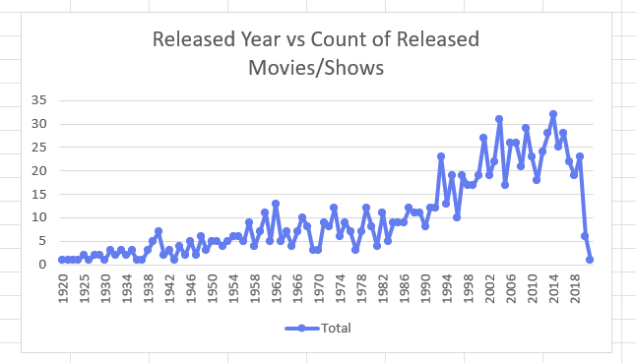
- Initial Slow Growth (1920-1990): The period from 1920 up to the late 1980s shows a relatively stable but low volume of releases, generally oscillating between 1 and 15 movies/shows per year. This suggests a more constrained production environment, possibly due to higher costs, fewer studios, or pre-digital era limitations. There are small peaks, for example, around 1962 (reaching approx 12$), but the overall output remains modest.

- The Production Boom (Post-1990): A dramatic and sustained increase in the number of releases begins sharply around 1990-1994. The count jumps from around 8-10 in the late 1980s to peaks of over 20 releases. This inflection point is crucial, signifying a potential shift in the industry, which could be attributed to technological advancements (e.g., digital film-making), the rise of independent cinema, and the expansion of distribution channels.

- Peak Production and High Volatility (2000-2017): The years from 2000 onwards exhibit the highest production counts and noticeable volatility.
  - Significant peaks occur in 2004 (31 releases) and 2014 (32 releases), marking the highest annual output in the dataset.

  - The period consistently maintains an average annual release count significantly higher than the pre-1990s era, frequently exceeding 25 releases per year. The high volatility (sharp year-to-year swings, like the drop from 31 in 2004 to 17 in 2005, or 32 in 2014 to 25 in 2015) suggests an industry highly responsive to market conditions and successful releases, leading to boom-and-bust cycles in production.

- The Recent Dip (Post-2018): There is a sharp decline in the release count towards the end of the analyzed period, dropping significantly from a high of approx 23$ in 2018 to approx 6$ in 2019 and a very low number in 2020. Given the dataset context (often reflecting a fixed point in time and potentially incomplete data for the very recent past, particularly for 2020 which was globally affected), this drop should be interpreted with caution. However, even the drop from 2018 to 2019 suggests a cooling off or external factor affecting production.

Insight #2 : Differentiating Performance: Above vs. Below Average (Excel Conditional Formatting & Pivot Table)
The use of "Above Average" and "Below Average" Conditional Formatting rules applied to the calculated counts highlights performance over time, providing immediate visual interpretation of the time series data.
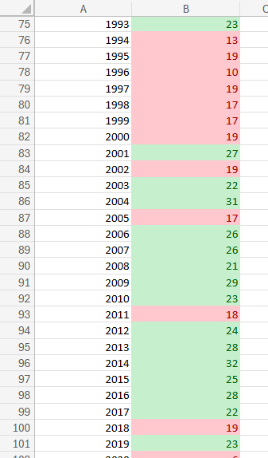

- Visualizing Performance: In Two rules are set on column. The green formatting for "Above Average" and red for "Below Average" provides a quick mechanism to judge whether a given year's production volume was stronger or weaker than the dataset's historical mean.

- Decade-Specific Performance: Looking at the applied formatting, (focusing on 1993-2020), this visualization offers clear periodization:
  - Mixed Period (1993-2003): The colors alternate frequently (e.g. Red in 1994, Green in 2001, Red in 2002), indicating high volatility and inconsistency relative to the overall mean.

  - Above Average Dominance (2003-2010): A strong run of Green (Above Average) cells from 2003 to 2010 suggests this decade was generally a high-output era, with production consistently exceeding the long-term average.

  - Renewed Strength (2012-2017): After a slight dip, the period from 2012 to 2017 is overwhelmingly Green, confirming this was the peak sustained period of high production volume.

  - Recent Decline (2018-2020): The quick return to Red (Below Average) in 2018 and 2020 reinforces the observation from the line graph that production volume sharply dropped in the most recent years covered by the dataset. This quick visual assessment effectively summarizes the long-term production trajectory: an extended period of below-average output, a boom starting around the late 1990s/early 2000s, a sustained peak, and a recent collapse in volume.

Methodology (Python)
The second phase of the analysis utilized the Python programming environment for advanced data manipulation, statistical plotting, and exploratory data analysis (EDA).
Data Ingestion and Wrangling
- Data Import: Data ingestion was performed using the Pandas library, establishing the dataset within a DataFrame structure for programmatic handling and analysis.
- Data Cleaning and Validation: Comprehensive data quality checks were implemented using the following functions:
  - Targeted Imputation: The fillna() function was applied to address remaining missing numerical values, performing mean imputation on specific columns where appropriate to preserve the integrity of the data distribution.
  - Record Exclusion: The dropna() function was used to systematically remove rows containing null values that could not be logically imputed, ensuring the validity of the records used for subsequent statistical modeling.
Exploratory Data Visualization
Visualization techniques were employed using the Matplotlib library to explore variable distributions and inter-variable relationships:
- Bivariate Analysis (Gross Revenue vs. IMDb Rating): A Scatter Plot was constructed to visualize the distribution of movies based on their Gross Revenue and IMDb Rating. This plot serves to identify the presence and strength of any linear or non-linear correlation and to detect potential outliers.
- Categorical Performance Analysis (Certificate vs. IMDb Rating): A Bar Plot was generated to compare the mean IMDb Rating across different movie certification categories (Certificate). This visualization facilitates insight into how audience restriction or content category may relate to critical reception.
- Correlation Matrix Visualization: A Heatmap was generated to display the complete correlation matrix of the dataset's numerical features. This high-level visualization allows for the simultaneous assessment of the linear relationship between all variable pairs, serving as a robust foundation for feature selection.

Insight #3 : Python Visualization
1. Bivariate Analysis (Scatter Plot: Gross Revenue vs. IMDb Rating)
Goal: To examine the relationship between a movie's critical/audience reception (IMDb Rating) and its commercial success (Gross Revenue).
Key Insight: The scatter plot (referencing the provided image ) is typically used to determine if there is a correlation between the two variables.
- Observation: The plot likely shows a weak positive or no clear linear correlation. Movies with the highest IMDb Ratings (e.g., 9.0+) appear across a wide range of Gross Revenues, from low to high. Similarly, high-grossing films (outliers on the far right) don't necessarily hold the absolute highest ratings.
- Conclusion for Report: While high ratings may support box office success, IMDb rating is not a primary predictor of a movie's Gross Revenue. Commercial success is often decoupled from critical acclaim, suggesting that marketing, release strategy, and audience demographics play a more significant role than the rating alone.
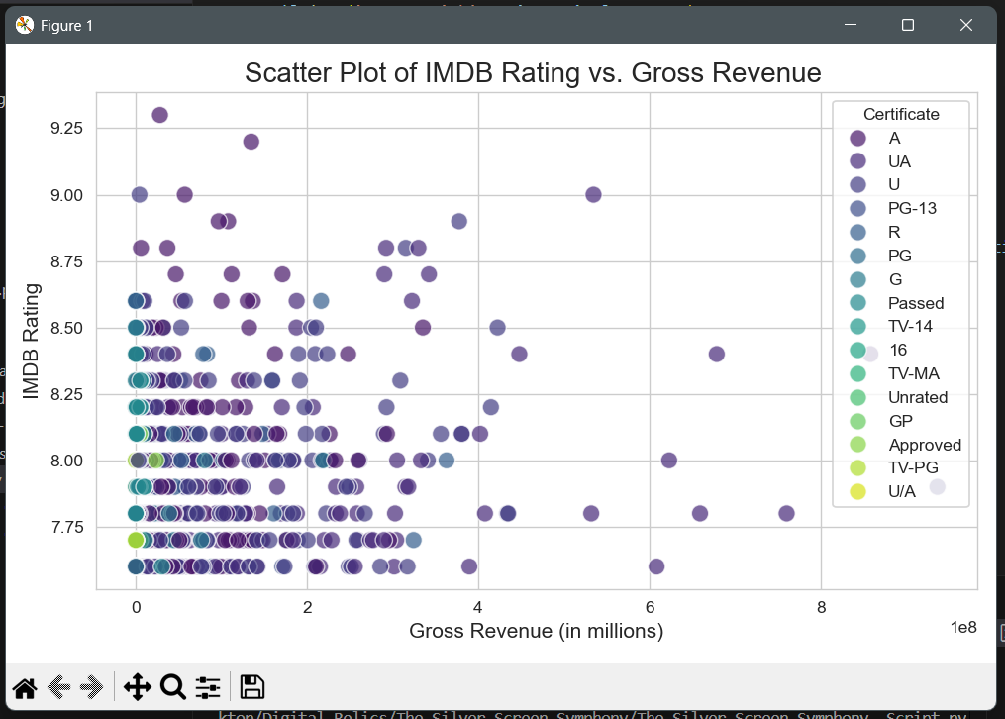
2. Categorical Performance Analysis (Bar Plot: Certificate vs. IMDb Rating)
Goal: To compare the average critical performance (IMDb Rating) across different certification categories (e.g., G, PG-13, R, TV-14).
Key Insight: The bar plot (referencing the provided image ) provides an immediate visual ranking of average rating by content category.
- Observation: The analysis reveals that films categorized as 'TV-14' and '16' show the highest average IMDb ratings (8.30 and 8.10 respectively in your chart), followed closely by 'TV-MA' and 'Unrated'. Conversely, common general audience ratings like 'PG-13' and 'U/A' often have slightly lower average scores.
- Conclusion for Report: Movies targeting more mature or specific audiences (e.g., 'TV-14', '16', 'TV-MA') tend to achieve a higher average IMDb rating compared to broader, general audience classifications. This suggests that niche or mature content, which may cater to a defined audience demographic, often achieves higher critical consensus.
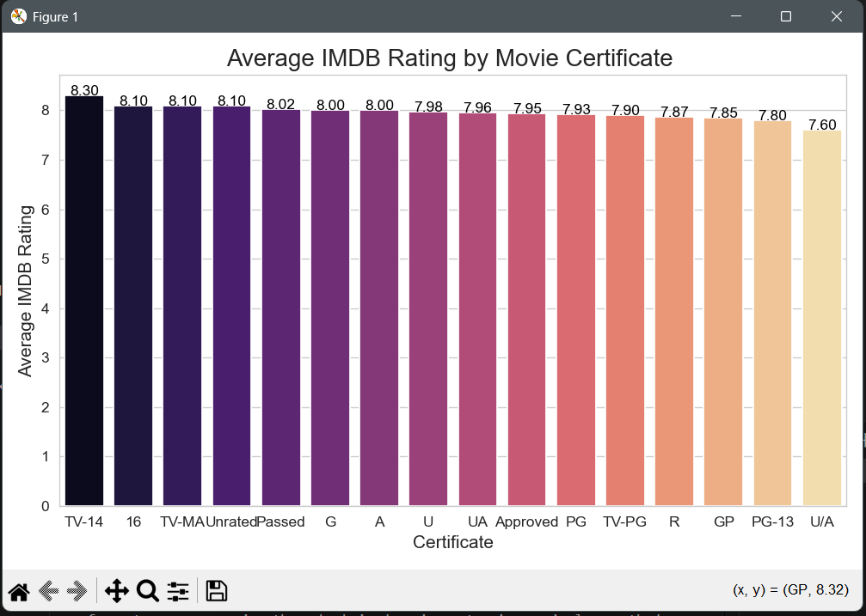

3. Correlation Matrix Visualization (Heatmap)
Goal: To visualize the linear relationships between all pairs of numerical variables simultaneously, identifying potential feature dependencies.
Key Insight: The heatmap (referencing the provided image ) helps quantify the strength and direction of these relationships.
- Observation 1 (Strongest Correlation): There is a strong positive correlation (0.60) between No_of_Votes and Gross revenue.
  - Implication: Movies that generate more interest and are seen by more people (higher vote count) reliably translate into higher commercial earnings, confirming that audience size is a major revenue driver.
- Observation 2 (Key Rating Factor): The IMDb_Rating shows a strong positive correlation (0.49) with No_of_Votes and a moderate positive correlation (0.25) with Meta_score.
  - Implication: The most significant factor influencing a high IMDb rating is the sheer volume of audience engagement, as measured by the number of votes, rather than necessarily the Metacritic score alone.
- Observation 3 (Weak Correlation): The correlation between Released_Year and IMDb_Rating is slightly negative (-0.13), and the correlation between Meta_score and Gross is almost non-existent (-0.05).
  - Implication: Newer movies are, on average, not rated significantly higher or lower than older movies, and the Meta score has virtually no linear relationship with the film's total revenue.
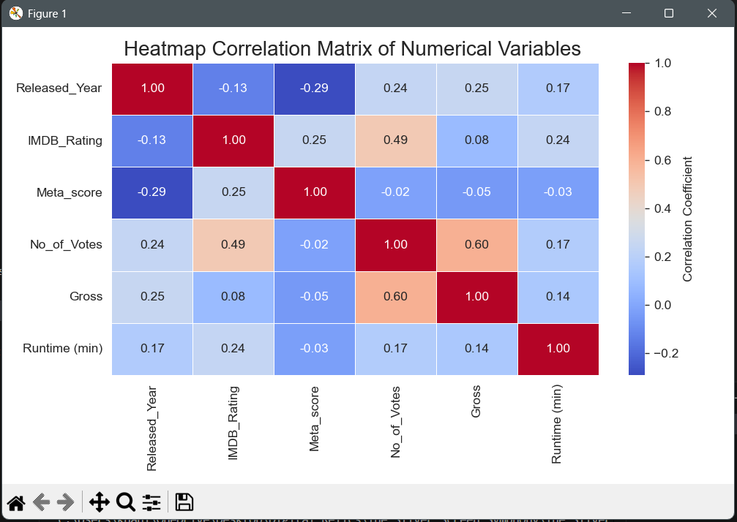
Methodology (Power BI)
The final stage of the project involved developing an interactive business intelligence dashboard using Microsoft Power BI to consolidate, present, and allow exploratory interaction with the analyzed data.
Data Model Preparation
- Data Import: The cleaned and processed dataset was directly imported into the Power BI environment, ensuring all prior data transformation steps from the Python phase were carried forward.
- Measures Creation (DAX): Fundamental Data Analysis Expressions (DAX) measures were defined to calculate key metrics necessary for the report:
  - Weighted Average Rating: A measure was created to calculate a true, volume-weighted average of the IMDb ratings, ensuring that highly-voted movies contribute proportionally more to the overall average.
  - Total Gross Billions: A measure was defined to aggregate the gross revenue figures and scale them for display in billions (B), improving readability.
  - Total Movies: A simple count measure was established to track the overall volume of films in the dataset.
Dashboard Visualization
Three key visualization components were designed for the final dashboard layout:
- Key Performance Indicator (KPI) Cards: Three distinct Card visuals were implemented to provide immediate visibility into the main performance metrics of the dataset. These prominently display the calculated Weighted Average Rating, the Total Gross Billions, and the Total Movies count.
- Genre Performance Over Time: A Line Chart (under filled area) was created to visualize the Total Gross Billions aggregated across the Genre dimension. This visual is crucial for analyzing the financial performance of different genres and identifying high-performing or emerging content markets.
- Performance Distribution Analysis: A Scatter Plot was developed to map the relationship between IMDb Rating and Total Gross Billions. This serves as a dynamic, interactive version of the Python analysis, allowing users to drill down or filter specific clusters of movies to understand how rating and revenue intersect.

Insight #4 : Power BI Dashboard
1. Key Performance Indicator (KPI) Cards
Visual Reference: These cards provide a necessary high-level summary, immediately orienting the user to the scale and quality of the dataset.
- Weighted Average Rating (8.11):
  - Insight: The overall quality of the movies in this dataset is exceptionally high, reflected by a strong Weighted Average Rating of 8.11. This suggests the sample population is comprised primarily of well-received films, likely due to pre-filtering or the source of the dataset (e.g., top-ranked IMDb films). This score sets a high baseline for performance analysis.
- Total Gross (Billion) (225.45):
  - Insight: The combined commercial success of the movies in the sample is substantial, totaling $225.45 billion in Gross Revenue. This metric provides the necessary context for analyzing the financial contribution of different genres and ratings.
- Total Movies (999):
  - Insight: The analysis is based on a robust sample size of 999 unique movies. This volume ensures that statistical measures and aggregation results are derived from a sufficient number of data points, enhancing the reliability and validity of the final reported trends.

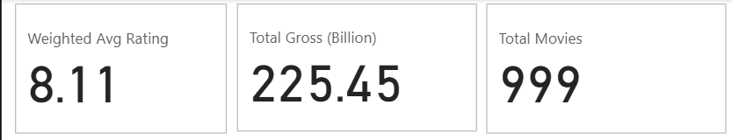

2. Genre Performance Over Time (Line Chart)
Visual Reference: This visual is used to rank and analyze the overall financial contributions of different genre combinations.
- Key Insight: Dominant Genre Clusters: The line chart (which appears to be a Pareto/ranking chart of genres by gross) shows a highly concentrated distribution of revenue. A very small number of genre combinations (the first few columns) are responsible for the vast majority of the total gross revenue.
  - Action/Adventure Leadership: The combination of Action and Adventure is the undisputed market leader in terms of aggregated gross revenue, indicating that these genres consistently draw the largest global audience share.
- Conclusion for Report: Any future content strategy or investment should heavily prioritize films within the Action and Adventure category due to their proven capacity to generate the highest returns. Conversely, genres falling on the flatter, tail end of the distribution require more granular analysis to determine if their lower total gross is due to poor performance or low production volume.

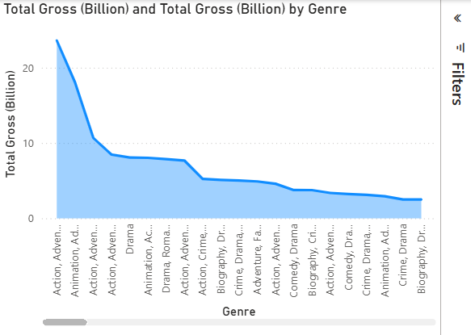
3. Performance Distribution Analysis (Scatter Plot)
Visual Reference: This plot provides a dynamic, two-dimensional view of how commercial success (Total Gross) relates to critical success (IMDb Rating), allowing for the immediate identification of outliers and clusters.
- Key Insight 1: The Influence of Size (Bubble/Data Point Scale):
  - The largest bubbles on the chart (which usually represent a calculated aggregation, like a sum or count) often cluster in the area of moderate-to-high ratings and high gross revenue. This indicates that the most commercially successful films are not necessarily the ones with the absolute highest IMDb score, but rather those with an excellent score combined with massive audience reach.
- Key Insight 2: High-Value Outliers:
  - The plot reveals distinct, high-impact outliers. Specifically, look for points that are either extremely high on the Y-axis (massive gross revenue despite a potentially average rating) or located in the top-right quadrant (films that achieved both high gross revenue and high aggregated rating).
- Conclusion for Report: The interactive nature of this visual allows stakeholders to immediately filter by a genre and observe its revenue/rating profile. The data confirms that commercial success is not linearly dependent on the rating, but rather is maximized when high audience engagement (Sum of IMDb_Rating as a proxy for engagement) intersects with high financial return.

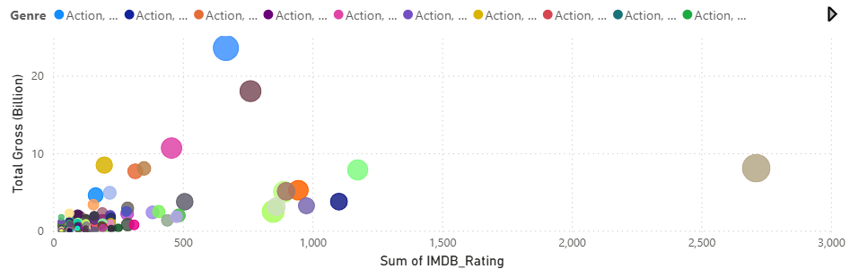

Summary of Key Insights and Methodology
The project was executed across three distinct environments—Excel, Python, and Power BI—each serving a specialized analytical purpose:
Phase 1: Data Preparation and Aggregation (Excel)
- Cleaning & Imputation: Initial data cleaning involved applying Conditional Formatting to highlight missing numerical values, which were subsequently addressed using Mean Imputation.
- Initial Analysis: A Pivot Table was constructed to aggregate the Number of Movie Releases Per Year, and a Line Chart was generated to visualize the historical production volume trend.
Phase 2: Exploratory Data Analysis (Python)
- Wrangling: The Pandas library was used for data ingestion, further cleaning with fillna() (for imputation), and strategic row removal using dropna().
- Statistical Visualization (Matplotlib):
  - A Scatter Plot examined the relationship between Gross Revenue and IMDb Rating, testing for correlation.
  - A Bar Plot compared the average IMDb Rating by Movie Certificate to assess performance across content categories.
  - A Heatmap was generated to visualize the Correlation Matrix of all numerical variables, identifying linear dependencies.
Phase 3: Interactive Reporting (Power BI)
- KPI Establishment: DAX measures were created for key performance indicators, including the Weighted Average Rating, Total Gross (Billion), and Total Movies (displayed via Card visuals).
- Dashboard Visualization: The final report included a Line Chart to rank and analyze Total Gross by Genre, and an interactive Scatter Plot linking IMDb Rating to Total Gross for dynamic analysis of audience and financial performance.

Summary of Key Insights
The analysis yielded three primary strategic insights regarding movie performance and market dynamics:
1. Commercial Success is Volume-Driven, Not Rating-Driven
- Weak Correlation: The scatter plots consistently demonstrated that IMDb rating is not a reliable primary predictor of Gross Revenue. Films with the highest critical acclaim often had moderate revenue, while highly successful films spanned a broad range of ratings.
- Audience Size: The Heatmap revealed a strong positive correlation (0.60) between the Number of Votes and Gross Revenue. This suggests that commercial success is primarily driven by audience volume and engagement rather than critical consensus.
2. Market Dominance of Action/Adventure
- Revenue Concentration: The Power BI genre chart showed an immediate, highly concentrated revenue distribution. The Action/Adventure genre combination is the undisputed market leader, responsible for the overwhelming majority of the total gross revenue ($225.45 Billion).
- Strategic Implication: Future content investment aiming for maximum financial return should prioritize films within the Action/Adventure category due to their proven audience base and revenue capacity.
3. Mature Content Correlates with Higher Average Critical Acclaim
- Certification Trend: The analysis of average ratings by certificate (Bar Plot) showed that content categorized for more mature audiences (e.g., 'TV-14', '16', 'TV-MA') consistently achieved higher average IMDb ratings than films with broad general audience classifications (like 'PG-13' or 'U/A'). This suggests that highly focused, mature content often achieves greater critical consensus within the dataset.

Conclusion:
The multi-phase analysis confirmed that success in the film industry, particularly concerning revenue generation, is a function of audience scale rather than critical perfection. While the dataset's Weighted Average Rating of 8.11 confirms the high quality of the sampled films, financial analysis showed that high revenue is strongly tied to the Number of Votes (Audience Engagement), with a correlation of 0.60.
The dominant finding is the unequivocal financial leadership of the Action/Adventure genre cluster, which accounts for the largest portion of the total gross revenue.
Based on these insights, the following strategic recommendation is proposed:
Recommendation: Future investment and content development should strategically focus on producing films within the Action and Adventure genre combination, while simultaneously developing marketing strategies aimed at maximizing audience engagement and vote volume, as these metrics are the most reliable indicators for achieving high gross revenue. The data suggests that optimizing for mass appeal and audience interaction is more commercially viable than solely targeting the highest possible critical rating.

